Veggie Pad Thai
By: Annie Sheldon

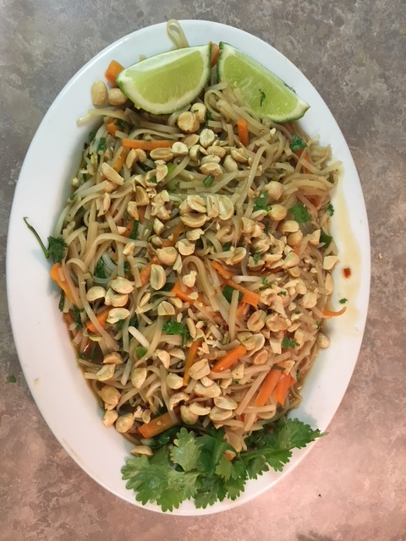

Ingredients

For the Pad Thai:
8 ounces brown rice Pad Thai noodles (new whole grain)
Small bunch of green onions
2 carrots
2 cup bean sprouts
2 tablespoons olive oil
1/2 cup peanuts, chopped (legume)
1/2 cup fresh cilantro (*grown in our office garden)

For the Sauce:
¼ cup fish sauce or vegan fish sauce substitute
¼ cup brown sugar
¼ cup chicken or vegetable broth
2 tablespoons white vinegar
1 tablespoon soy sauce
1 tablespoon chili paste

Instructions

- Place the uncooked noodles in a bowl of cold water to soak.
- Chop the green onions and carrots.
- Shake up the sauce ingredients in a jar.
- Heat a tablespoon of oil over medium high heat. Add the veggies – stir fry with tongs for 2-3 minutes or until tender-crisp. Be careful not to overcook them. Transfer to a dish and set aside.
- Add another tablespoon of oil to the pan. Drain the noodles – they should be softened by now. Add the noodles to the hot pan and stir fry for a minute, using tongs to toss. Add the sauce and stir fry for another minute or two, until the sauce is starting to thicken and stick to the noodles.
- Add in the vegetables, toss together, and remove from heat. Stir in the peanuts and cilantro and serve immediately.

